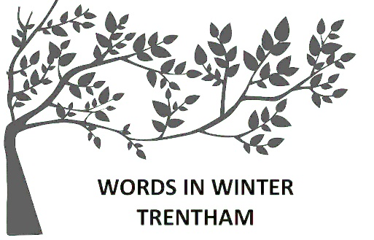**Red Beard 50-word stories**

**ENTRY FORM**

***Theme: open***

**Name: _____**___________________________ **P’code:** ______ **Age** (if under 18): ____

**Phone:** __________________ **email: ______**__________________________________

Write your entry below: EXACTLY 50 words, no hyphens!

_________________________________________________________________________________________

_________________________________________________________________________________________

_________________________________________________________________________________________

_________________________________________________________________________________________

_________________________________________________________________________________________

_________________________________________________________________________________________

_________________________________________________________________________________________

*Entries close at* ***3pm August 13 2023****. The winner receives a $50 voucher to use at Red Beard Bakery.*

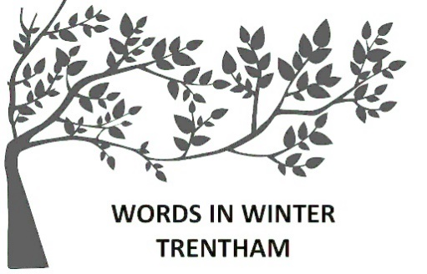**Red Beard 50-word stories**

**ENTRY FORM**

***Theme: open***

**Name: _____**___________________________ **P’code:** ______ **Age** (if under 18): ____

**Phone:** __________________ **email: ______**__________________________________

Write your entry below: EXACTLY 50 words, no hyphens!

_________________________________________________________________________________________

_________________________________________________________________________________________

_________________________________________________________________________________________

_________________________________________________________________________________________

_________________________________________________________________________________________

_________________________________________________________________________________________

_________________________________________________________________________________________

*Entries close at* ***3pm, August 13 2022****. The winner receives a $50 voucher to use at Red Beard Bakery.*